Name:____________________________________

Quiz C:
Differentiation Proficiency. -- NO CALCULATOR ALLOWED!
Simplify as much as possible (you do NOT have to factor, however).
Put a box around your final answer.

(1) 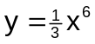

(2) 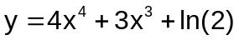

(3) 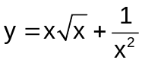

(4) 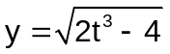

(5) 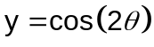

(6) 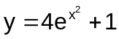

(7) 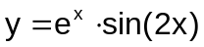

(8) 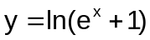

(9) 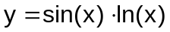

(10) 